全英文课程重学网上支付操作步骤
登录正方教务管理系统(www.gdjw.zjut.edu.cn/jwglxt)。
第一步：选择【信息维护】--【学生缴费】
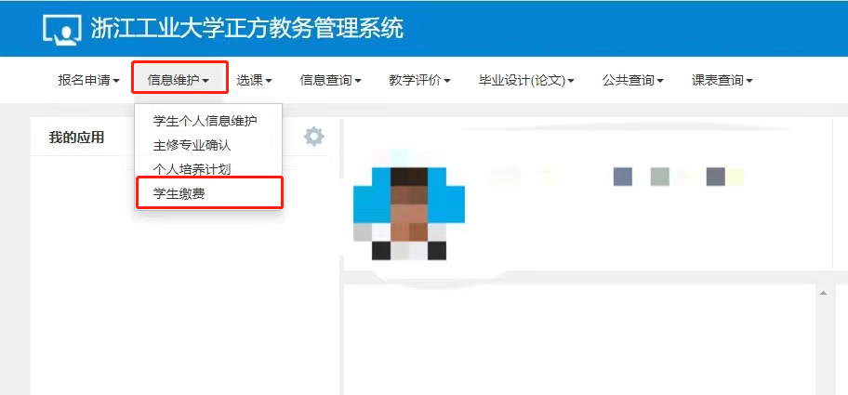

第二步：查询并确认需要缴费的重学课程
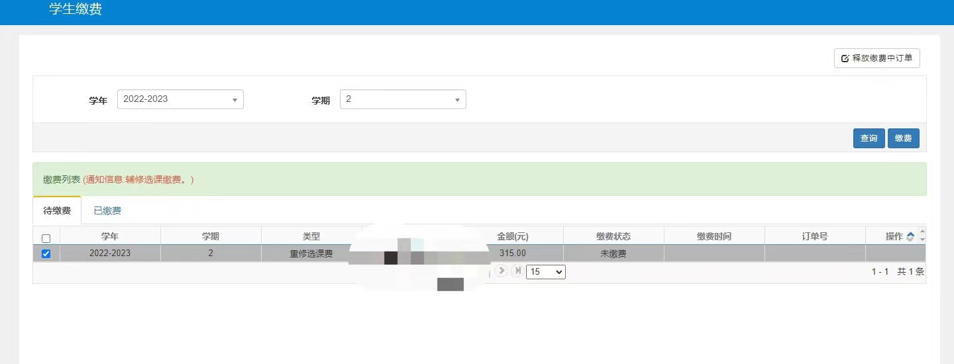
第三步：支付宝缴费：勾选需要缴费的项目，然后点击右上方缴费按钮。

因支付界面是弹出界面的方式，部分浏览器可能会拦截，如无界面弹出，请查看一下地址栏右边点击这个叉叉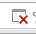出现以下对话框。
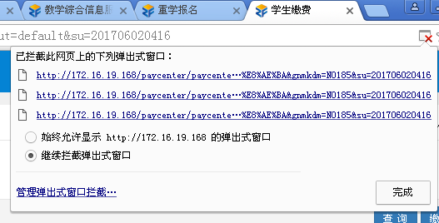
选择始终允许显示http://……的弹出式窗口，然后按完成按钮，对话框自动关闭后，重新按钮缴费按钮，弹出缴费对话框。
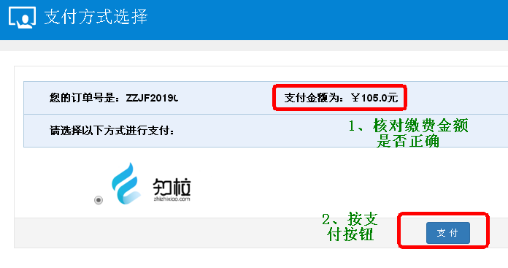
按支付按钮，出现缴费的二维码，用支付宝APP扫描二维码完成付款过程后，缴费成功。
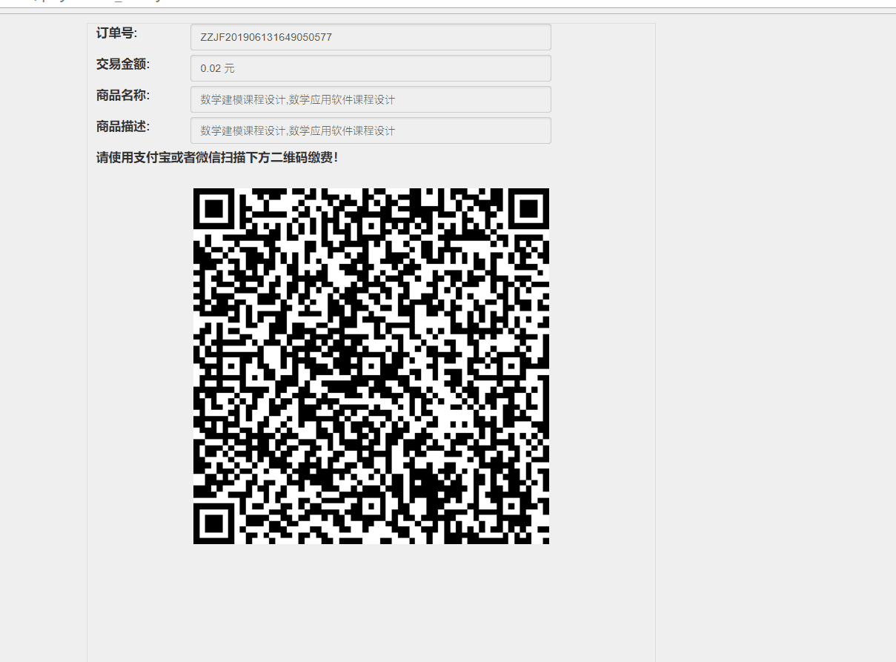
待缴费成功后，可以在已缴费的栏目中查看已缴费的情况。
说明：
请在缴费前，核对清楚重学报名课程，确认无误后，再进行缴费，缴费一旦成功后，不允许退课。

Steps on Online Alipay procedures of Retaking Courses in Zhengfang Educational Management System
Log in Zhengfang educational management system with off-campus network (www.gdjw.zjut.edu.cn/jwglxt) with Google Chrome browser.
Step one: Select “Information Maintenance” — “Student Payment”
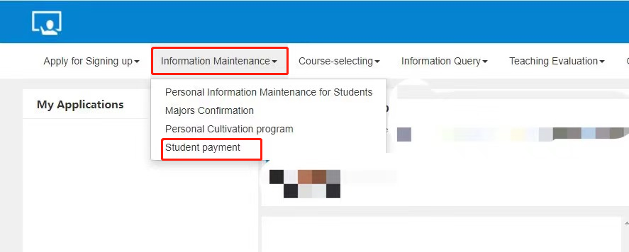
Step two: Check and confirm your retaking courses.
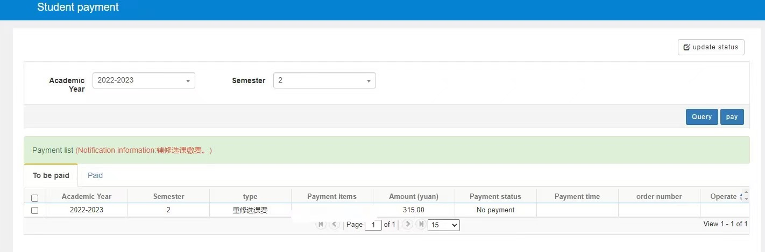
Step three: Select the retaking courses and press the button“Pay”.
Because payment interface is the way of pop-up interface, some browsers may intercept it. If no interface pops up, please check the right side of the address bar: click on the fork icon: then the following dialog box appears:
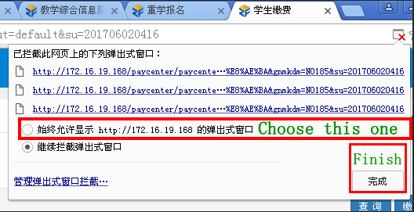
Select the item "Always allow http://...", then press the finish button. After the dialog box is automatically closed, click the payment button again and pop up the payment dialog box.
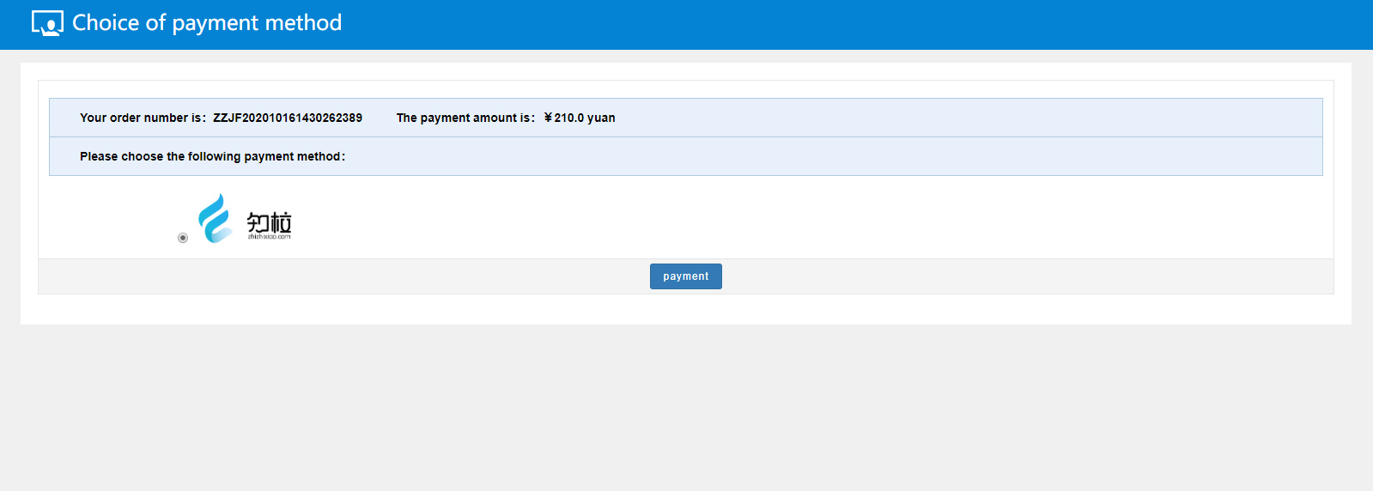
Click the payment button and a two-dimensional payment code appears. Use Alipay APP scan the two-dimensional code to complete the payment process, then the payment is successful.
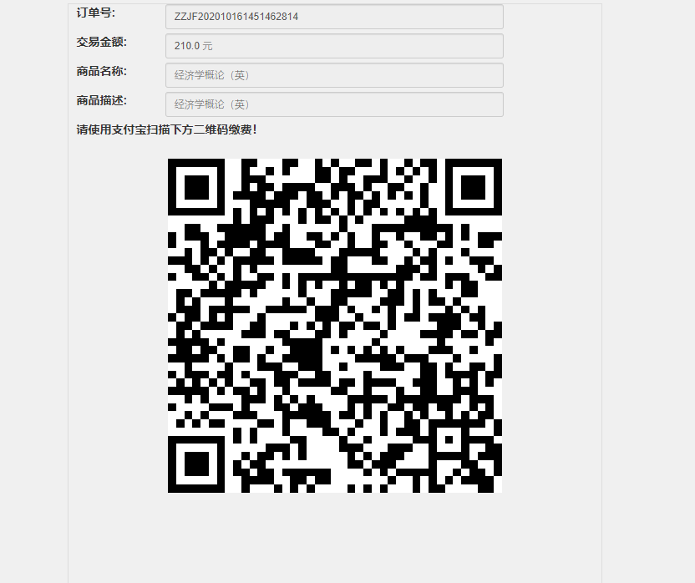
When the payment is successful, you can check the status of the payment.
Attention:
Please check the courses before paying the fee, confirm that it is correct, and then pay the fee. Once the payment is successful, it is not allowed to drop out.

