正方教务管理系统课程重学网上报名及支付宝缴费操作步骤
用Google Chrome浏览器登录正方教务管理系统：www.gdjw.zjut.edu.cn/jwglxt（校外链接）。
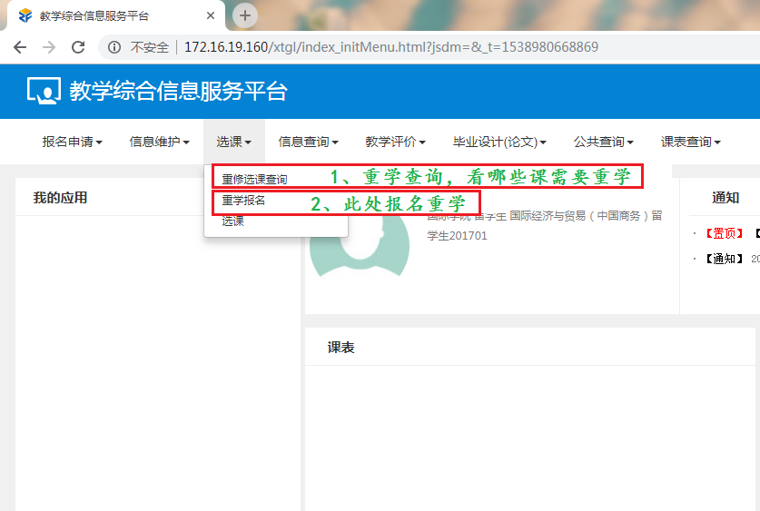
首先了解有哪些课程需要重学，可以在选课重修选课查询里面查看。
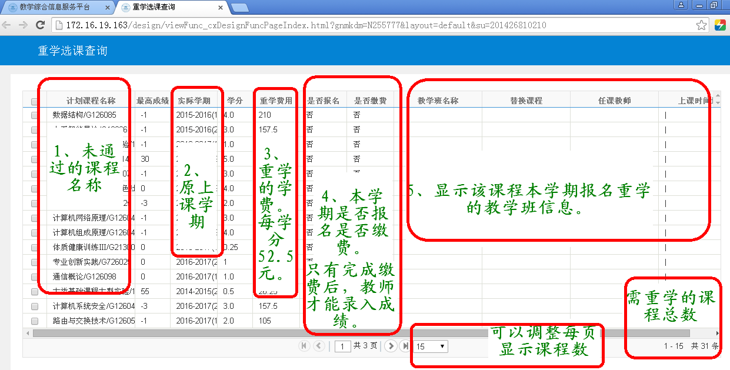
本界面不限制访问时间，随时可以查看。本界面上显示的是所有需要重学的课程清单。
之后可以进行重学报名，在选课重学报名中进行报名操作。
温馨说明：
- 打开重学报名界面后，系统查询可能时间较长，请耐心等待。
- 界面上显示的课程，都是本学期开设的，可报名的课程。其他有部分课程需要重学的，但是本学期未开课的，在此界面上不显示。如有问题，请与所在专业学院联系。
- 本界面只有在重学报名期间开放。重学报名期间外，需在重修选课查询界面上查询选课情况。
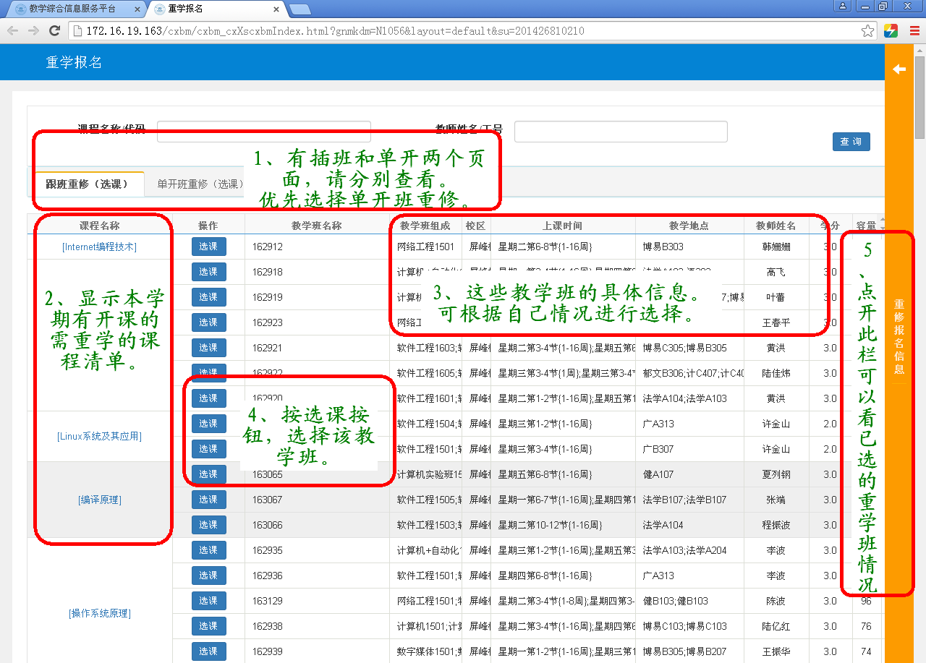

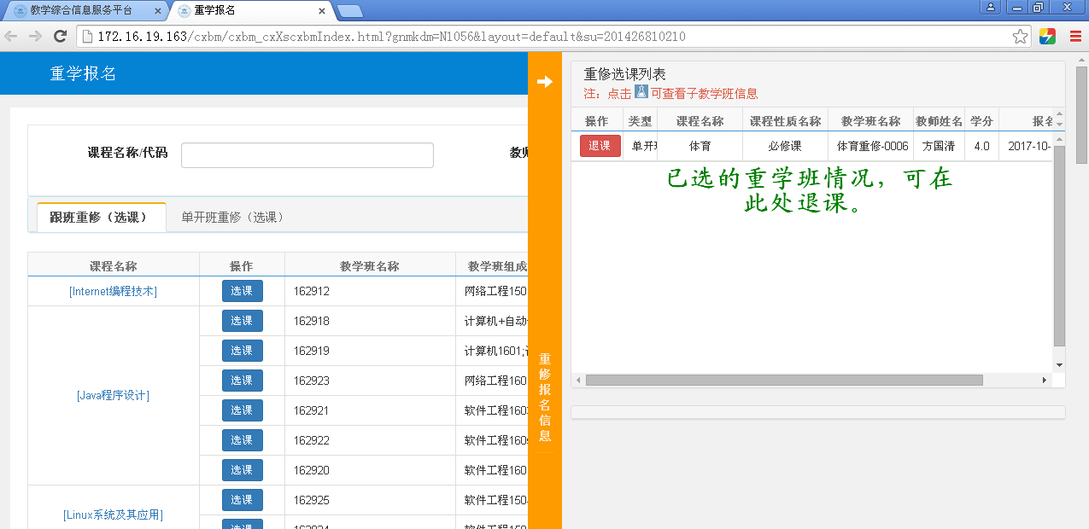

支付宝缴费流程说明：
在报名完成后，可以点击窗体右上角的缴费按钮，进行支付宝缴费。
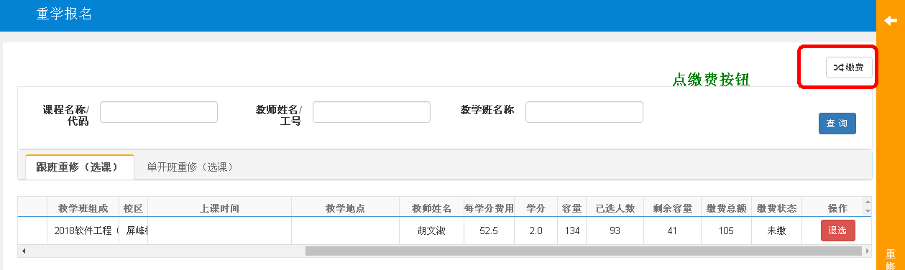

之后出现缴费界面：
2020/2021（1）学期的重学报名缴费学期请选1。
例如2019短学期选择的应选 学年 2018-2019 学期 3。选好学期后，按查询按钮，在待缴费列表中出现重学的课程清单，请选择课程后，按缴费按钮。
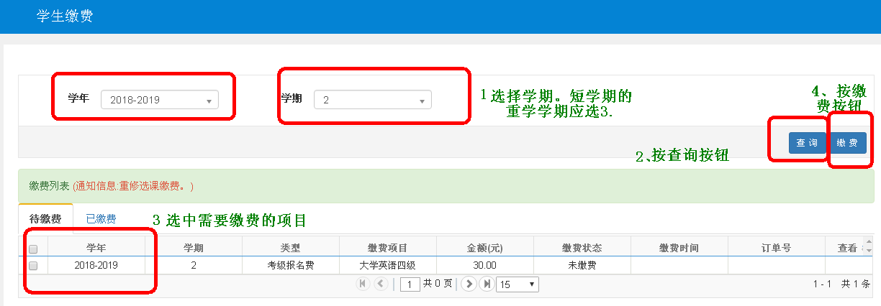
因支付界面是弹出界面的方式，部分浏览器可能会拦截，如无界面弹出，请查看一下地址栏右边点击这个叉叉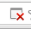出现以下对话框。
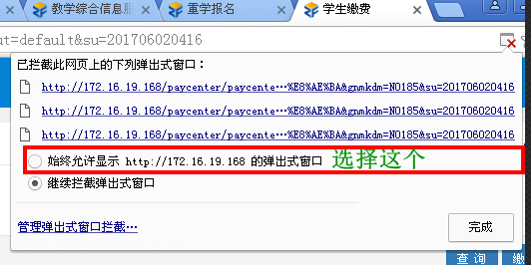
选择始终允许显示http://……的弹出式窗口，然后按完成按钮，对话框自动关闭后，重新按缴费按钮，弹出缴费对话框。
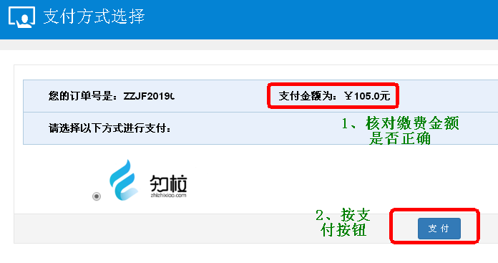
按支付按钮，出现缴费的二维码，用支付宝APP扫描二维码完成付款过程后，缴费成功。
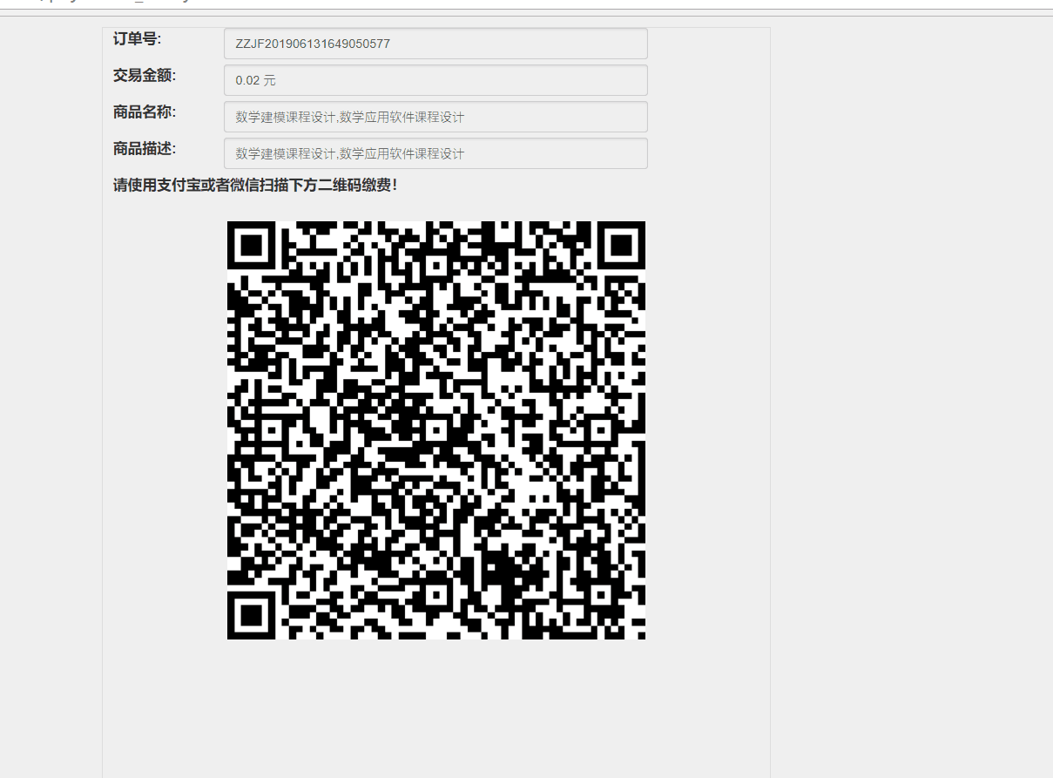
待缴费成功后，可以在已缴费的栏目中查看已缴费的情况。
说明：
请在缴费前，核对清楚重学报名课程，确认无误后，再进行缴费，缴费一旦成功后，不允许退课。

Steps on Online Registration and Alipay procedures of Retaking Courses in Zhengfang Educational Management System
Log in Zhengfang educational management system with off-campus network (www.gdjw.zjut.edu.cn/jwglxt) with Google Chrome browser for registration.
Switch the language here
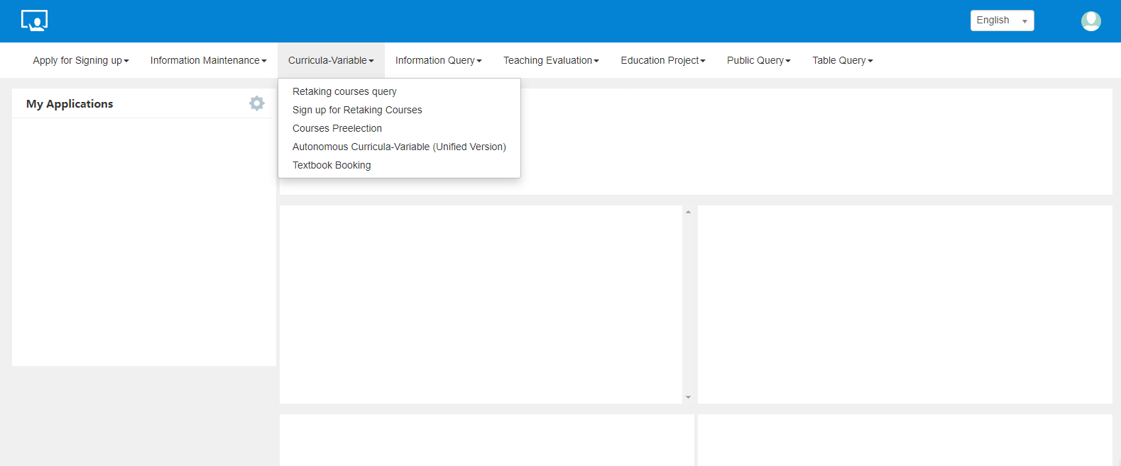
- Check which Retaking courses you need.
- Sign up for Retaking Courses.
First, check which courses you need to retake on the page of registration and retaking courses query.
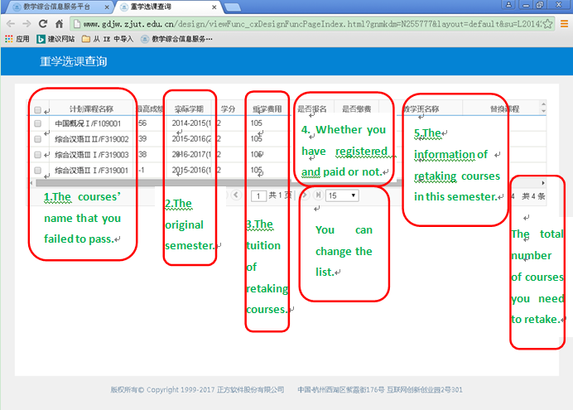
The page of retaking courses query is accessible anytime. You can check the list of retaking courses on this page.
Then you can register for your retaking courses on the page of retaking courses registration.
Tips:
1. Please be patient to wait for loading pages.
2. The page only shows the courses available this semester. The courses for other semesters will not be listed. If you have any questions, connect with your own college.
3. The page of registration is accessible only during the registration time.
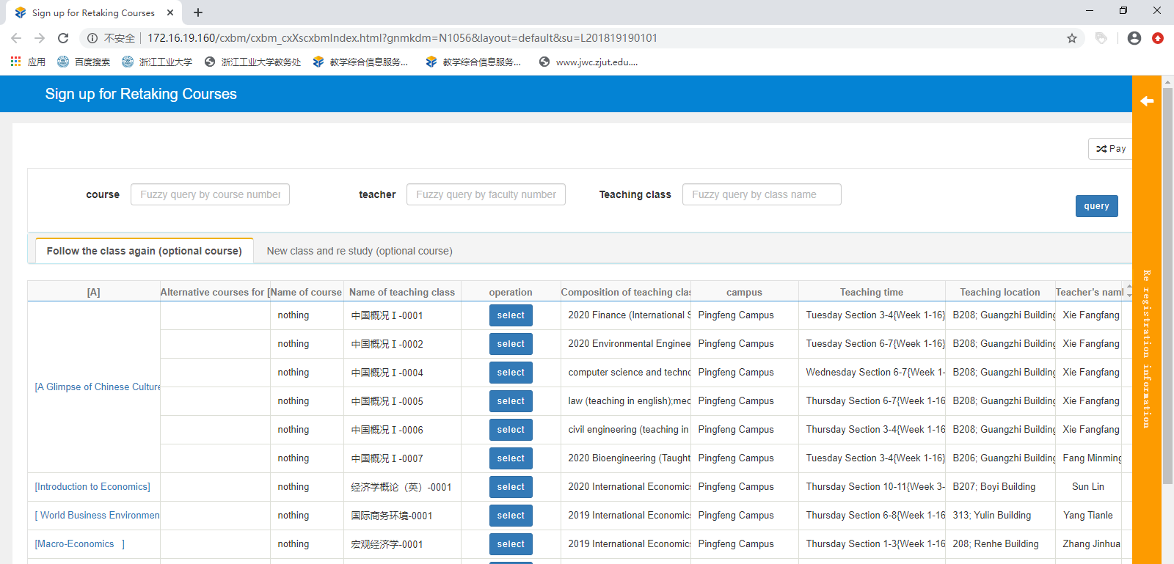
4. Click here to select the class.
2. List of retaking courses available this semester.
5. Click here to see the classes you have chosen.

3. The information about the classes. Choose them according to your own schedule.

1. There are two pages: transfer to general classes or special classes for retaking only.

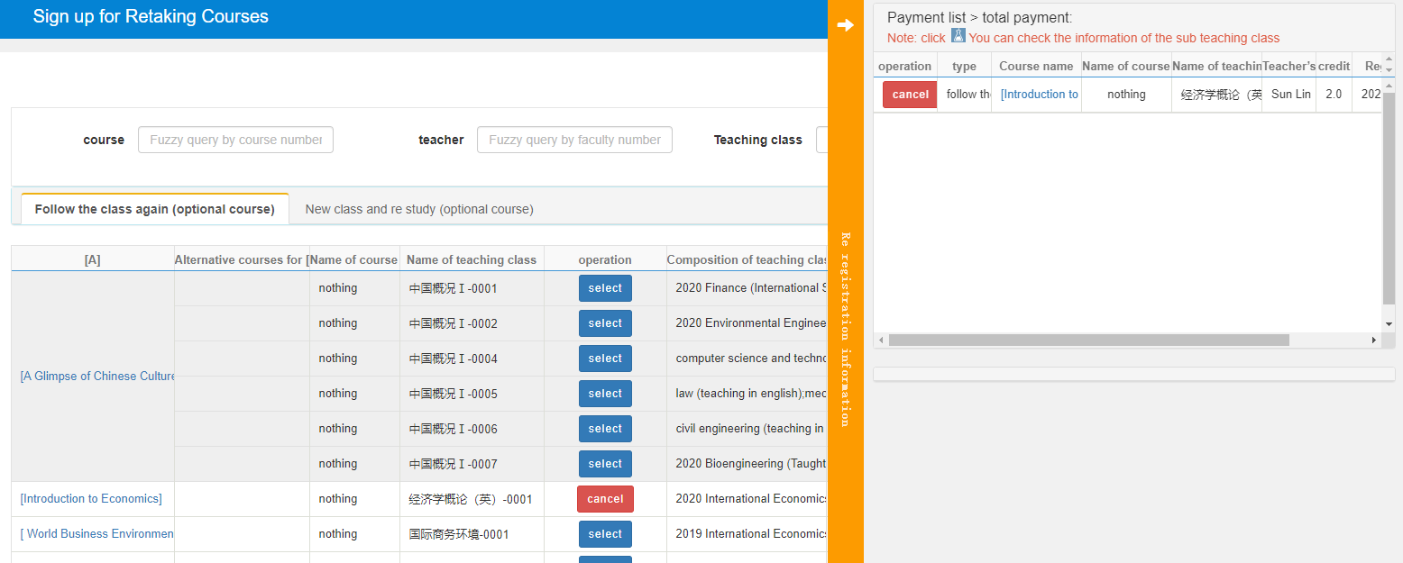
Here you can see the list of retaking courses you have chosen and you also can cancel them.

Payment process of Alipay:
After course registration, you can click on the payment button on the upper right corner of the page to pay by Alipay.
Click the button “Pay”
Subsequently, the payment interface appears:
For 2020/2021(1) semester, please select Academic Year 2020-2021 and Semester 1.
For example, in 2020/2021（1）semester, academic year 2020-2021, semester 1 should be selected.
After choosing the semester, press the inquiry button and the list of retaking courses appears in the list of pending fees. After choosing the courses, press the button “Pay”.
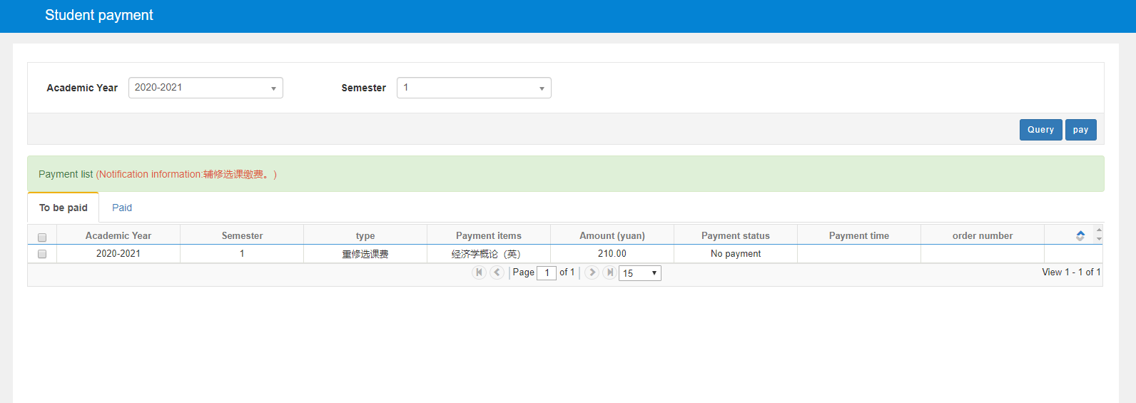
4. Click the button “Pay”
1. Choose “Academic Year” and “Semester”
2. Click the button “Query”.
3. Select the courses that need to be paid.
Because payment interface is the way of pop-up interface, some browsers may intercept it. If no interface pops up, please check the right side of the address bar: ,click on the fork icon: , then the following dialog box appears:
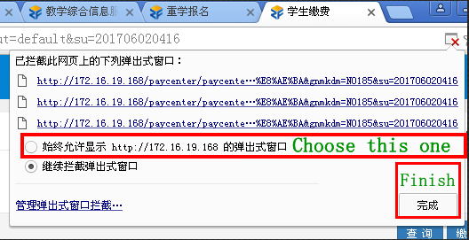
Select the item "Always allow http://...", then press the finish button. After the dialog box is automatically closed, click the payment button again and pop up the payment dialog box.
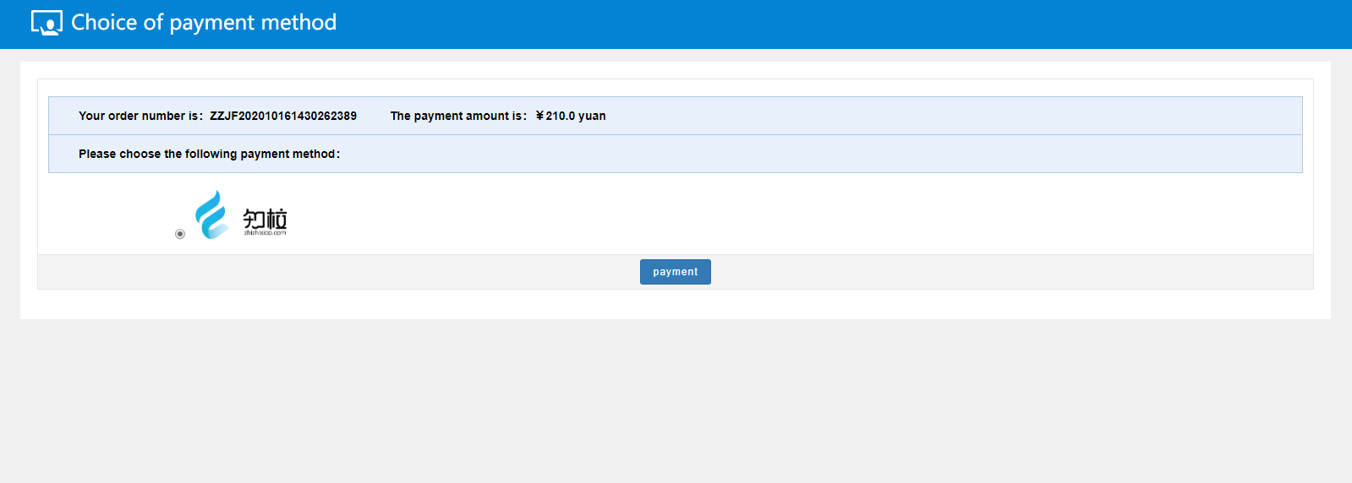
2. Click the button “Payment”.
1. Check whether the payment amount is correct.

Click the payment button and a two-dimensional payment code appears. Use Alipay APP scan the two-dimensional code to complete the payment process, then the payment is successful.
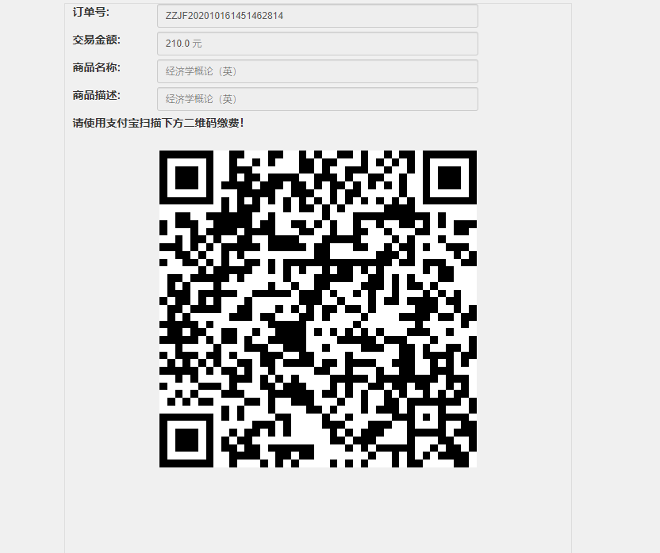
When the payment is successful, you can check the status of the payment.
Attention:
Please check the courses before paying the fee, confirm that it is correct, and then pay the fee. Once the payment is successful, it is not allowed to drop out.

