正方教务管理系统课程重学网上报名操作步骤
用Google Chrome浏览器登录正方教务管理系统http://172.16.19.160/（校内）、http://www.gdjw.zjut.edu.cn/（校外）。
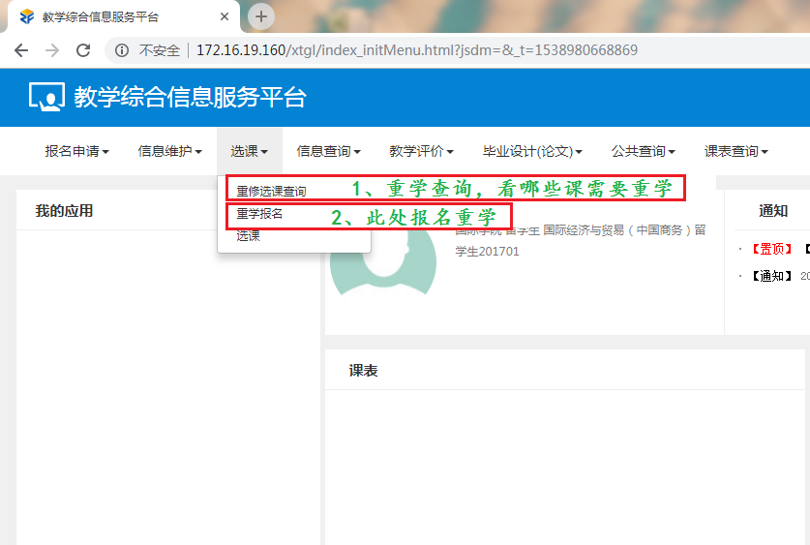
首先了解有哪些课程需要重学，可以在选课重修选课查询里面查看。
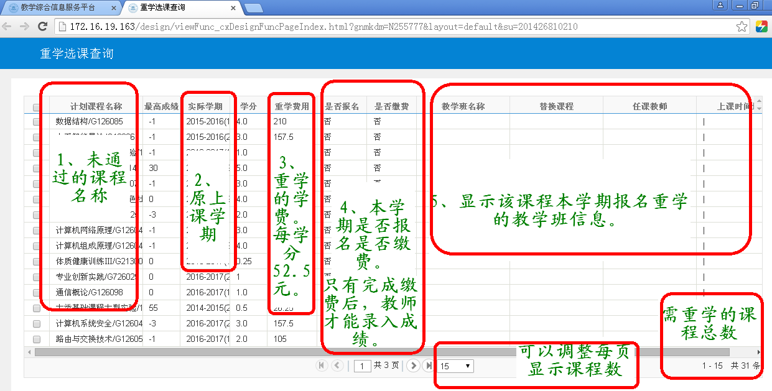
本界面不限制访问时间，随时可以查看。本界面上显示的是所有需要重学的课程清单。
之后可以进行重学报名，在选课重学报名中进行报名操作。
温馨说明：
- 打开重学报名界面后，系统查询可能时间较长，请耐心等待。
- 界面上显示的课程，都是本学期开设的，可报名的课程。其他有部分课程需要重学的，但是本学期未开课的，在此界面上不显示。如有问题，请与所在专业学院联系。
- 本界面只有在重学报名期间开放。重学报名期间外，需在重修选课查询界面上查询选课情况。
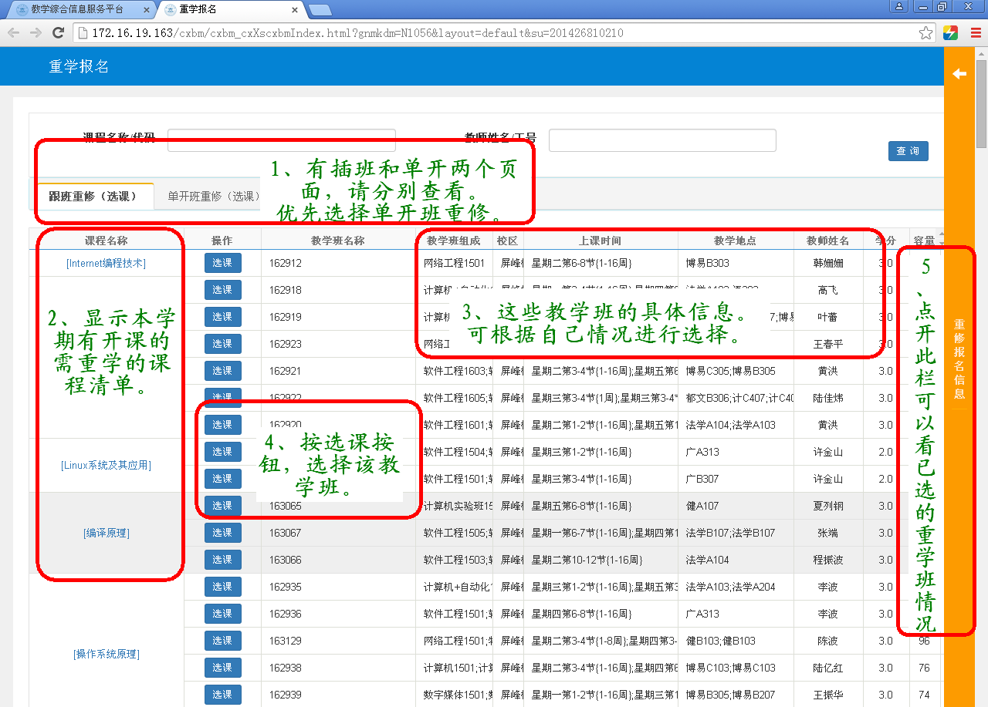

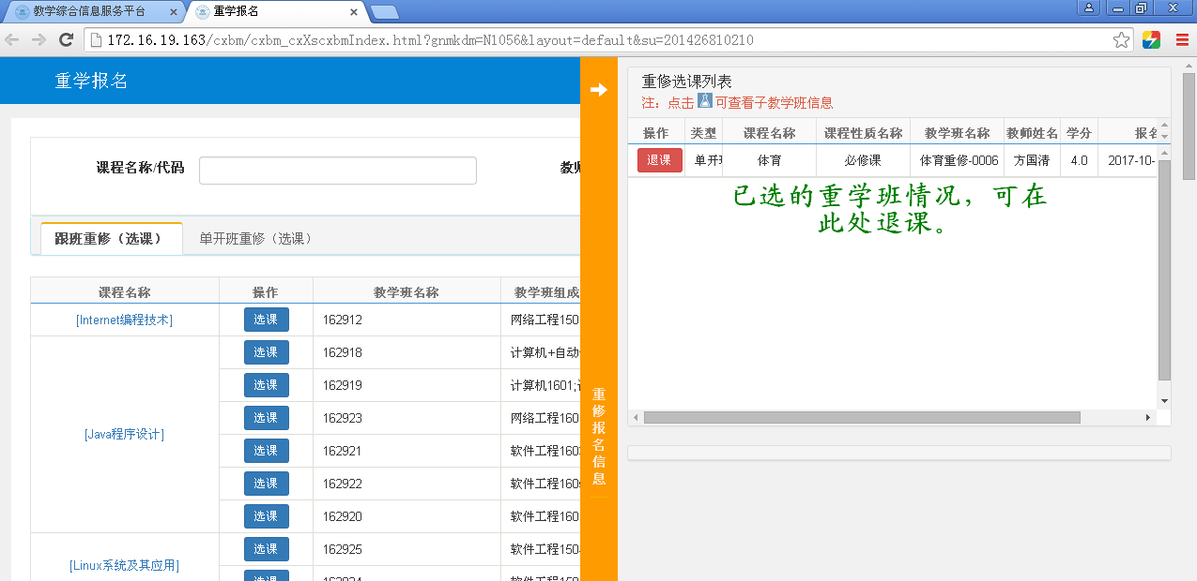
完成网上报名后，请留学生到国际化培养办公室（屏峰：健行楼B405，朝晖：东科教楼南楼112）开重学缴费通知单，然后持重学缴费通知单到计财处（屏峰：健B418，朝晖：东科教楼北楼101）缴现金（2016级及之前按52.5元/学分收取，2017级及之后按105元/学分收取）。完成缴费后，请留学生务必带收据到国际化培养办公室确认重学资格。若不按时缴费，则作自动放弃重学处理。

Steps on Online Registration of Retaking Courses in Zhengfang Educational Management System
Log in Zhengfang educational management system (http://172.16.19.160) with Campus Network or (www.gdjw.zjut.edu.cn) with Common Network with Google Chrome browser for registration.
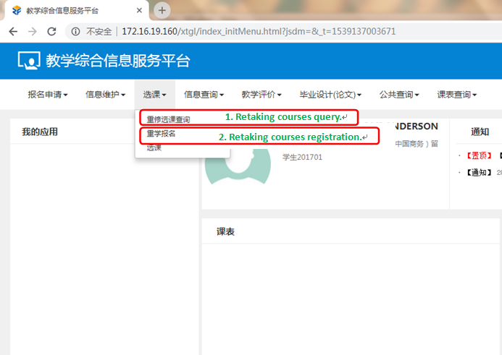
First, check which courses you need to retake on the page of registration and retaking courses query.
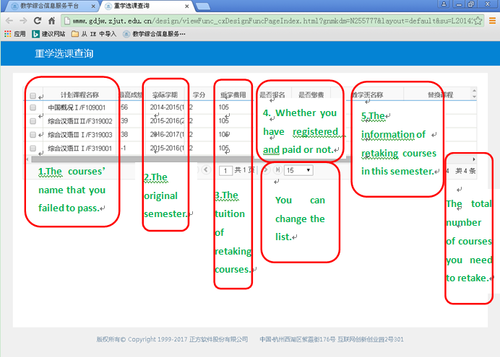
The page of retaking courses query is accessible anytime. You can check the list of retaking courses on this page.
Then you can register for your retaking courses on the page of retaking courses registration.
Tips:
1.Please be patient to wait for loading pages.
2.The page only shows the courses available this semester. The courses for other semesters will not be listed. If you have any questions, connect with your own college.
3. The page of registration is accessible only during the registration time.
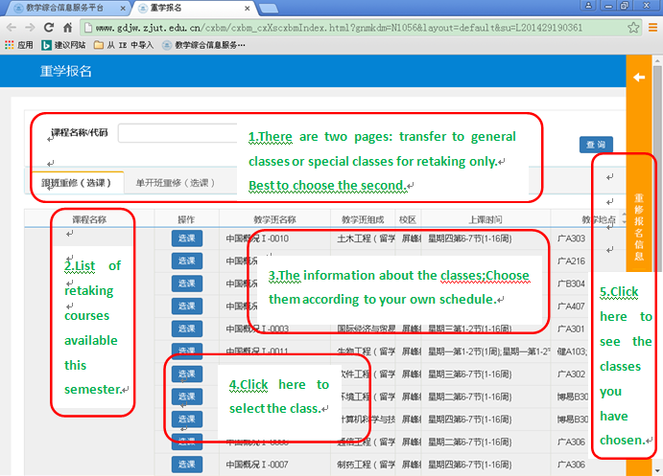

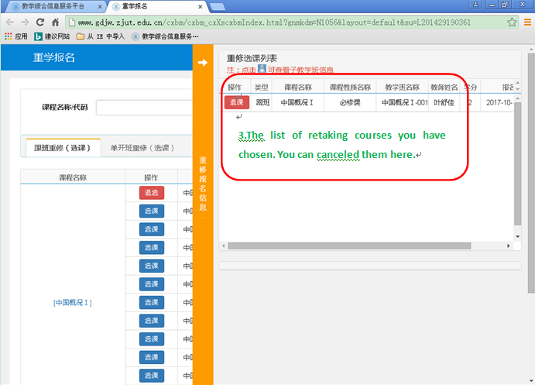
After registration, international undergraduate students shall go to the International Education Office (Pingfeng Campus: Jianxing Building B, Room 405, Zhaohui Campus: South Dongkejiao Building , Room 112) to get a payment notice after registering online. Then students shall go to the Financial Office (Pingfeng Campus: Jianxing Building B, Room 418, Zhaohui Campus: North Dongkejiao Building , Room 101) with the payment notice to pay in cash. The tuition of retaking courses is 52.5 Yuan per credit for students who were enrolled in or before 2016, 105 Yuan per credit for students who were enrolled in or after 2017. International undergraduate students shall go back to the International Education Office with receipt to confirm the retaking courses qualification after payment. If students do not pay in time, it is regarded as giving up retaking courses qualification.

